The Garden House at Casa Nova : key facts at a glance
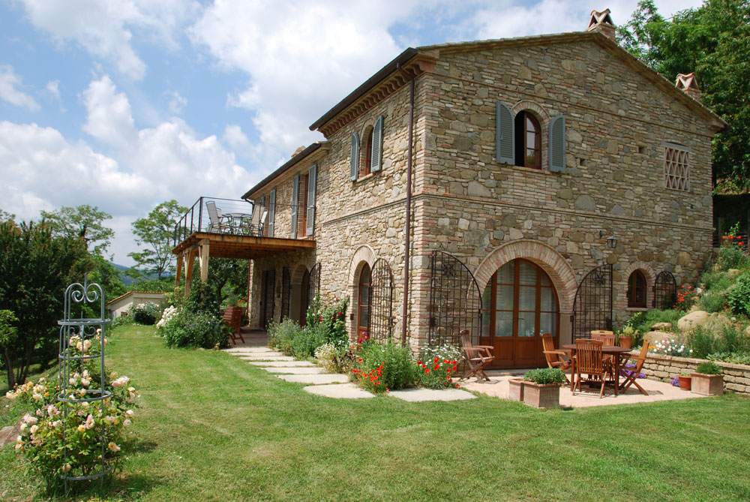
4 bedroom house with own pool (11m x 5m) in Umbria, half an hour from Perugia. Available for holiday rentals all year round. The Garden House at Casa Nova is an idyllic location from which to discover Umbria, Southern Tuscany and the Marche. Casa Nova is a small fruit and olive farm, 500m above sea-level on the southfacing slope of the beautiful Niccone valley, 30 minutes from Perugia, the capital of Umbria and the same from Cortona, in Tuscany. The Garden House sits in its own terraced garden on the estate, overlooking an orchard and the pool, below. The land has been farmed organically since the 1980s and is a haven for wildflowers and wildlife. The surrounding countryside offers endless possibilities for walking and cycling. Lake Trasimeno is within easy reach for swimming and watersports. The artistic treasures of Cortona, Perugia, Assisi, Urbino and the Upper Tiber Valley are all close to hand. Florence, Siena and Rome are a daytrip away. For driving times to key sites and to airports, see website. There are many excellent restaurants and plenty of activities nearby to keep everyone happy. Prices from 1,500 euros per week. See Calendar and pricing on website for full prices and availability.
- Sleeps 6 to 9 (cots available for up to two infants).
- Indoors: 4 bedrooms and 4 luxurious bathrooms, all en-suite; huge, very fully-equipped kitchen; washing machine and drier; Satellite tv (card not included); stereo; plenty of books and dvds; broadband internet and network, pc, printer/fax; solar panels, underfloor heating and large stone fireplace (firewood provided); towels, swimming towels, bedlinen and weekly cleaning included.
- Pool: 11m x 5m; generous area of decking for sunloungers; fenced access.
- Outdoors: pretty garden surrounded by fruit trees, olives and wildflowers; shaded pergola and large, sunny balcony; plenty of outdoor furniture, barbecue; panoramic views; gather your own seasonal fruit and vegetables from the garden and eggs from the free range chickens; 25 acres of unspoilt countryside to explore around the house.
- Perfect peace for stressed-out City dwellers (since circa 100 A.D.); freedom for kids to roam and play (plus: selection of children’s books; videos/dvds; toys; assortment of bikes for kids and adults; trailer bike; climbing frame, swings and den; cots; highchair available).
- Direct flights from London Stansted and Frankfurt (Ryanair) to Perugia (less than 40 minutes away) or alternatively fly to Bologna, Forli, Florence, Pisa or Rome. See location map and getting there on website.

As working parents (barrister and art historian) with three school-age kids, we spent years looking for the perfect place for family holidays and we’ve put that experience into designing and equipping the Garden House. We have tried to create a home-from-home, with comforts to suit all seasons and all ages. The Garden House is available for holiday rentals year round. 2008 rates range from €1500-3000 pw.
Guided art-historical tours, cookery classes, babysitters, preparation of meals and extra cleaning can be arranged if required.
Some comments from guests in 2007:
“This has been a fantastic holiday and the best possible introduction to Umbria. The house has been a great base for us and has a real sense of family and home. The attention to detail in the design and finish of the house is first class...For our families it doesn’t come better than this and we will be back.”
“This really is 5 star accommodation. You have thought of everything and more - even toys for the wee one. We could have done with three weeks not two weeks as we were torn each day between relaxing here and visiting the many wonderful towns - we would recommend this to anyone.”
To enquire about booking the Garden House email rentals@casanovaumbria.eu or phone or text Dr Tom Henry on 07850-408167.
For more photographs and to check prices, location and availability of the Garden House, visit www.umbrianeden.it. Or, for more in-depth information about the Garden House, about Casa Nova and about holidaying in Umbria, go to our main website at www.casanovaumbria.eu.
